|  |  |
| --- | --- |
| 28 February 2022 | SWP Ref: 2204456  SWP-SIR- 2204456 Rev.A |

Pattersons Insurerbuild Pty Ltd

C/- Duha Mohammed

PO Box 5030

Heidelberg West VIC 3081

**Building/Engineering Report**

**Insured:** St Brigid's Church - Mordiallo

**Address:** 518 Main street, MORDIALLOC, VIC 3195

**Insurer:** Catholic Church Insurance - SE

**Insurer Ref No:** 3947512

**Builder:** Pattersons Insurerbuild Pty Ltd

**Builder Ref No:** 384644

**Site Inspection: 14 February 2022 – 4.00 pm**

Thank you for your instruction dated 4 February 2022 to inspect and provide a report on our findings at the above address; specifically, you have requested that we report on the following:

***“Attend to provide engineering report. Insured have advised  that during the claimed event they could see from inside the building the roof framework lifting off the external  walls and believe there may be structural damages requiring a further assessment from an engineer.”***

# Overview

The property in question is a double-storey masonry constructed Church building supporting a metal sheeted roof. **Image 1**

The ceiling is raked (cathedral) ceiling consists of timber ceiling boards affixed to underside of the roof frame.

According to provided information, subsequent to a storm event occasioning the area in approximately September 2021, a section of the upper roof corresponding to the southwest alignment was partially uplifted.

For referencing purposes, an aerial site plan of the subject property in the orientation of True North has been provided in ***Figure 1***.

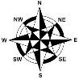

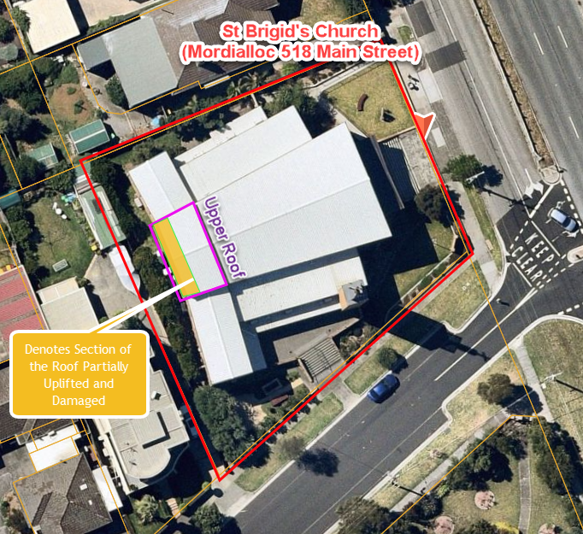

Figure 1- Aerial Site Plan of Subject Property

# Observation, Comments & Discussion

*Photos Attached As Appendix*

Inspection was undertaken at the subject property to which the following storm damage was noted:

1. We have undertaken a drone survey of the roof surfaces within the subject Church in ascertaining the extent of damage to the roof cladding. **Image 2**
2. According to our drone survey, we noted evidence of damage to the section of roof cladding, ridge capping and barge capping corresponding to the southwest alignment of the upper roof consistent with the subject storm event. **Image 3**
3. At the time of our inspection, the detached section of roofing had been reinstated to its original position and remained in place.
4. In our opinion, the aforementioned affected roof elements will require partial removal and reinstatement inclusive of all associated flashing, fixings and connections in accordance with *AS 1562.1:2018 Design and Installation of Sheet Roof and Wall Cladding* and NCC BCA 2019 requirements.
5. We further inspected the adjacent lower roof surfaces to which no sign of damage or storm-crated opening was noted.
6. Moreover, we noted a number of cracked and loose brick units about the top course along the roof edge, which can be repaid by localised removal and reinstatement. **Image 4**
7. In addition, we noted cracking to a number of brick units corresponding to the wall rebate in close proximity to the area of concern. We note that the observed cracking is consistent with cyclic expansion growth of the brick units and unrelated to the subject storm event.
8. However, we note that the above-mentioned damage has no demeaning effect on the overall structural integrity of the supporting brick wall.
9. We note that from provided advice and our assessment, given the raked nature of the ceiling there is no access or limited access to the roof cavity to assess the roof framework.
10. As such, at the time of our inspection, we were unable to visually inspect the roof timber framework and the associated tie-down connections.
11. Having said that, in our opinion, the proximate cause of the observed damage to the roof is attributable to inadequate tie-down connections of the roof rafters to the supporting brickwork to resist the wind loading at the time of the event, which has resulted in roof uplift and localised damage to the brick units as outlined previously.
12. We note that the removal of the damaged roof sheet upon reinstatement works will allow for re-assessment of the roof framework, to which further investigation in ascertaining the roof integrity can be undertaken by a qualified carpenter.
13. In saying that, should the existing framework exhibit any sign of damage, the damaged members to be removed and replaced in accordance with *AS 1684.2 – Residential Timber-Framed Construction.*
14. According to our visual inspection from the internal ground level, we noted minor movement and separation of the ceiling timber mouldings from the brickwork about either side of the southwestern brick wall. **Images 5 - 7**
15. However, no evidence of major movement within the ceiling timber boards was noted to suggest that the roof framework has been compromised or there is an imminent risk of collapse.
16. In our opinion, given the raked nature of the ceiling, the ceiling timber panels are directly affixed to the roof main framework, and as such, the experienced uplift to the roof cladding has translated to the ceiling, causing the observed movement and separation from brickwork.
17. Further to the above, we noted damage to the existing downpipe servicing the lower roof along the southwest elevation, requiring reinstatement to match the existing size and profile inclusive of reconnection back to the existing stormwater system in accordance with *AS 3500.3:2021 - Plumbing and Drainage*. **Image 8**

# Conclusion

Identified damage to roofing elements, particularly about the southwest alignment of the upper roof, as detailed within the body of this report is consistent with the experienced storm event, which can be partially removed and replaced in accordance with the current relative Australian Standards and NCC BCA 2019 requirements.

From our drone inspection, no evidence of damage or distress to the supporting brickwork apart from a number of loose and cracked brick units about the top course was noted to suggest the overall structural integrity of the building has been compromised.

In our opinion, the damaged brick units can be locally removed and repointed to match the existing ones.

We note that from provided advice and our assessment, there is no access or limited access to the roof cavity to assess the roof framework, and as such, at the time of our inspection, we were unable to visually inspect the roof timber framework and the associated tie-down connections.

However, in our opinion, the proximate cause of the observed damage to the roof is attributable to inadequate tie-down connections of the roof rafters to the supporting brickwork to resist the wind loading at the time of the event, which has resulted in roof uplift and localised damage to the brick units.

We note that the removal of the damaged roof sheet upon reinstatement works will allow for re-assessment of the roof framework, to which further investigation in ascertaining the roof integrity can be undertaken by a qualified carpenter. Should the existing framework exhibit any sign of damage, the damaged members are to be removed and replaced in accordance with *AS 1684.2 – Residential Timber-Framed Construction.*

Moreover, we noted minor movement and separation of the ceiling timber mouldings from the brickwork about either side of the southwestern brick wall.

However, no evidence of major movement within the ceiling timber boards was noted to suggest that the roof framework has been compromised or there is an imminent risk of collapse.

In our opinion, given the raked nature of the ceiling, the ceiling timber panels are directly affixed to the roof main framework, and as such, the experienced uplift to the roof cladding has translated to the ceiling, causing the observed movement and separation from brickwork.

In addition, the existing downpipe servicing the lower roof along the southwest elevation has dislodged, requiring reinstatement to match the existing size and profile inclusive of reconnection back to the existing stormwater system in accordance with *AS 3500.3:2021 - Plumbing and Drainage*.

# Recommendations/Scope of Work

Given the limited and simple nature of the reinstatement works, a separate scope of works has not been provided.

Our Firm has provided the following reinstatement program in reinstating the resultant damage sustained during the subject storm event, which to be undertaken accordingly:

## Qualifications

### Roof Framework Reassessment

*Upon removal of the damaged roof sheet during the reinstatement works further investigation in ascertaining the roof integrity can be undertaken by a qualified carpenter.*

*Should the existing framework exhibit any sign of damage, the damaged members are to be removed and replaced in accordance with AS 1684.2 – Residential Timber-Framed Construction.*

### Roof Tie-Down Connections

*In facilitating assessment of the tie-down during the reinstatement works, we have provided details of a compliant tie down provisions for timber roof battens to rafters and rafters to load bearing brick walls.*

*Should during the reinstatement works, the existing roof tie-downs deemed to be inadequate and non-compliance against the provided details, allowance to be made in undertaking the necessary upgrading works in accordance with the provided structural drawings attached under* ***Appendix A****, in line with AS 1674.2 requirements.*

## Reinstatement Works

### Roof Cladding

1. Allow for removal and replacement of the damaged roof elements about the affected section of the upper roof (southwest alignment) inclusive of netting and all associated flashing, fixings and connections in accordance with *AS 1562.1:2018 Design and Installation of Sheet Roof and Wall Cladding* and NCC BCA 2019 requirements to match the existing. ***Approximately 61m2 GFA***
2. Allow for reinstatement of the barge cladding about the both gable ends of the upper roof to achieve the uniform and matching finish. ***Approximately* 25Lms**

### Roof Framework

1. Allow for reassessment of the roof framework upon removing of the roof sheet in ascertaining the integrity of the roof.
2. Should the existing framework exhibit any sign of damage, the damaged members are to be removed and replaced in accordance with AS 1684.2 – Residential Timber-Framed Construction.
3. Should the existing roof tie-downs appear to be inadequate and non-compliance against the current relevant Australian Codes, allowance to be provided in undertaking the necessary upgrading works in accordance with the provided structural drawings attached under ***Appendix A***, in line with AS 1674.2 requirements.

### Damaged Brick Units

1. Include for removal and repointing of the damaged brick units local to the top course of the brick wall corresponding to the southwest alignment of the roof. ***Approximately 20 off***

### Uplifted Timber Ceiling

1. Include for reinstating the uplifted ceiling timber panels supported off the southwest brickwork to its original position to match the existing condition.

# Qualification on any Reference Made to Current NCC BCA 2019, Australian Standards and/or Guidelines within the Report

We advise that any reference made to current NCC Building Code of Australia (BCA) 2019, Australian Standards and/or guidelines has ONLY been made to clarify and explain the mechanism of damage/occurrence unless clearly stated otherwise.

Such reference to current NCC BCA 2019, Australian Standards and/or guidelines is not for the purpose of compliance and/or conjecture about building/design/construction/workmanship defects unless clearly stated otherwise.

The Building Code of Australia (BCA) has developed and issued for the firsts time in 1988; however, this version of BCA was not adopted by any of the States and Territories up until the BCA 1990 version which was adopted at various dates by each States and Territories namely, ACT on 5/11/90, NSW on 1/1/92, NT on 18/12/91, QLD on 1/1/92, SA on 17/6/91, TAS on 2/11/94, on VIC on 8/4/91 and WA on 28/7/89.

In cases where the age of building and construction predates the above-mentioned adoption dates of BCA, we advise any reference made to BCA should not be used for assessment of either design, construction and/or workmanship defects.

# Closure

We confirm our report has been prepared in an objective and independent manner as a professional and Chartered Engineering and Licenced Building Firm subject to reference and application of qualified engineering method, factual and evidence-based assessment without prejudice.

We advise that our site inspection has only completed in areas where pertains to your instructions or requests/issues raised during inspection onsite. We confirm areas not included within this report was not subject of the instructions and/or safe access to the areas of concern was not available despite our reasonable attempts to undertake the inspection in those areas.

Our method of visual and non-destructive inspection, assessment and reporting has been completed with reference to the National Building Code of Australia (NCC BCA 2019), relevant Australian Standards, manufacture’s specifications and/or relevant state Guide to Standards and Tolerances where applicable.

We trust this meets your requirements and should you require further information or clarification on the matter, please do not hesitate to contact the undersigned.

Yours Faithfully,

**Silver Wolf Projects Pty Ltd**

|  |  |
| --- | --- |
| Prepared by: | Reviewed by: |
| Sohrab Kashani  Civil/Structural Engineer  B.E. (Civil), M.E (Structural) | Nik Housh  Associate Structural/Civil Engineer  B.E (Civil) M.Eng (Structural)  MIE Aust. CPEng NER RPEQ  C:\Users\Nick\Google Drive\Legal Docs\SIGNATURE.jpg |

# Appendix A – Typical Roof Tie-Down Structural Details

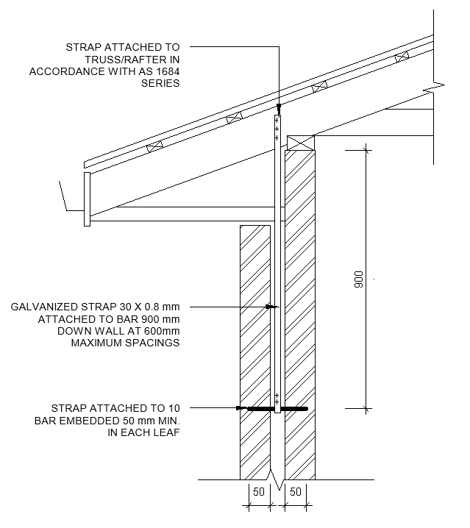

Figure 2 - Typical Roof Rafter to Masonry Wall Tie-Down Connection

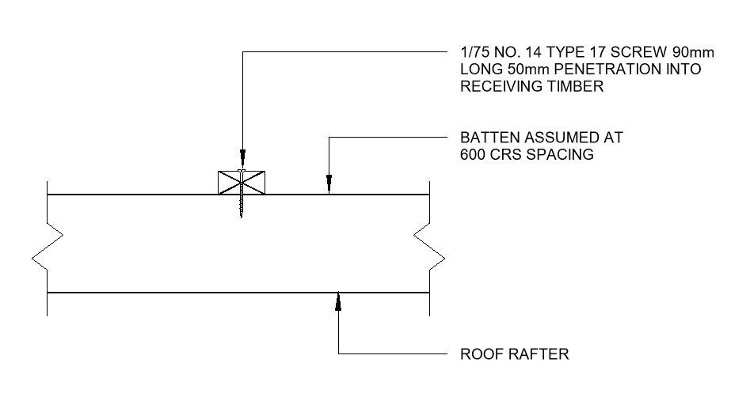

Figure 3 – Roof Battens To Rafters Tie-Down Detail (General Area)

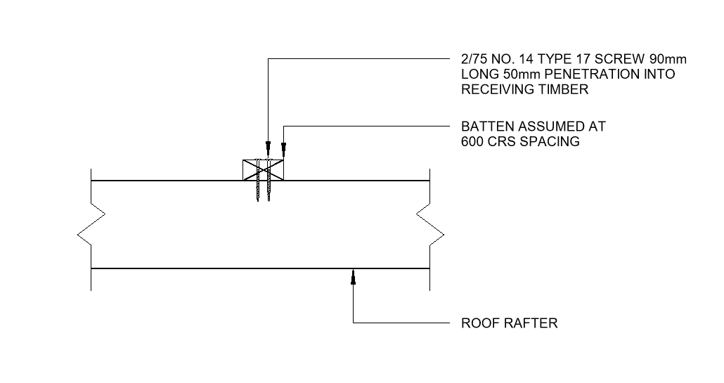

Figure 4 – Roof Battens To Rafters Tie-Down Detail (Within 1200mm of Edges)

# Images

|  |
| --- |
|  |
| **Image**  View of the Subject Church Elevation View |

|  |
| --- |
|  |
| **Image**  Drone Survey of the Subject Roof |

|  |
| --- |
|  |
| **Image**  View of the Storm Damaged Section of the Upper Roof Corresponding to the Southwest Alignment |

|  |
| --- |
|  |
| **Image**  View of the Localised Loose and Damaged Brick Units About the Top Course Corresponding to the Southwest Alignment of the Roof |

|  |
| --- |
|  |
| **Image**  View of the Ceiling Along the Supporting Brick Works Below the Uplifted Roof Cladding (Southwest Alignment) |

|  |
| --- |
|  |
| **Image**  View of the Minor Movement and Separation of the Ceiling From the Supporting Brick Works Below the Uplifted Roof Cladding (Southwest Alignment) |

|  |
| --- |
|  |
| **Image**  View of the Minor Movement and Separation of the Ceiling From the Supporting Brick Works Below the Uplifted Roof Cladding (Southwest Alignment) |

|  |
| --- |
|  |
| **Image**  View of the Damaged Downpipe Servicing the Lower Roof Corresponding to the Southwest Elevation |